Image Processing Steps

0. download a set from the google drive from AIDATA ->VALID DATA and select a set. name the folder on your local computer after the same name 'S1'

1. use anchortiff.m and orient the raw tiff according to the markers.

1a. there will be three markers. one will be the "corner marker" as shown in the figure below. Think of it as the marker diagonally opposite to the empty corner.

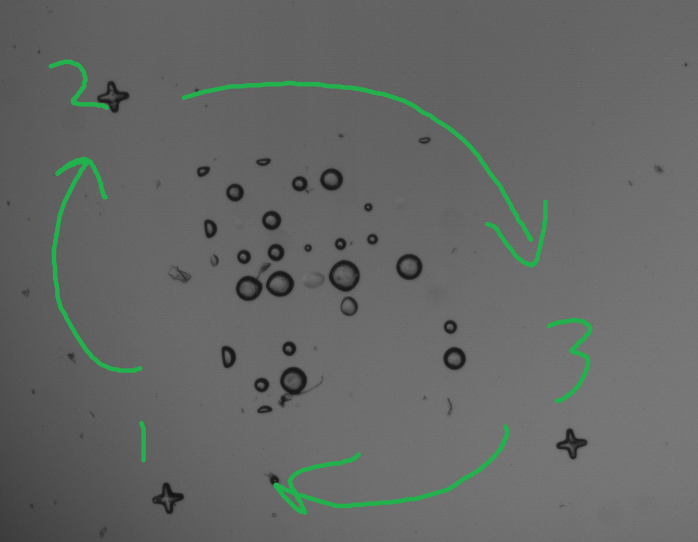

1b. select this marker first.

1c. the next marker to select will be the next one in the clockwise series.

1d. select the remaining marker. press enter.

1e. the next image will pop up automatically. repeat steps 1b-1d until all images are complete.

1f. anchortiff.m creates a folder in 'S_#' named 'anchored' and saves all the oriented tiff files in here~~. it also creates a big canvas of all the oriented tiffs in 'S_#' for easier edge filling in Paint.~~

~~2. use Paint to fill in edges for near-invisible underpolymerized for the big canvas and save as 'coloredbigcanvas' in 'S_#'~~

~~3. use splitter.m to split again into individual oriented tiff images into a folder named 'preprocessed'~~

~~3a. will prompt to select the canvas of colored tiff images.~~

~~3b. will prompt to select the raw tiff files contained in 'S_#'. (this is for naming purposes.)~~

4. use testq.m to do the actual conversion

4a. multiselect all the oriented tiff files in ~~'preprocessed'~~. ‘anchored’

4b. will display the first oriented tiff file of the series.

4c. enter a number 0-1 (prompted in matlab command window). may start around 0.5. press enter.

4d. enter a number 5-15 (prompted in matlab command window. may start around 5-10. press enter.

4e. if the edges are nicely defined, type 'y' and enter. if not, type 'n' and repeat steps 4c and 4d until edges are defined enough. Try different combinations.

-if you select 'n', exit the figure windows to avoid cluttering.

4f. use the cursor to click the solid parts of the print. if misclick, may backspace. make sure to click all the solid enclosed areas. if some areas are not enclosed completely, may leave that alone and fix later in paint.

4g. if you like the fill, type 'y' and press enter. if not, type 'n' and repeat 4f. if you type 'n', delete the figure window to avoid cluttering.

4h. all preprocessed binary files are saved in preprocessed along with the oriented tiff files.

if a mistake is made anywhere between steps 4c and 4g, may close the testq.m program with ctrl+C in the command window. Resume again by running testq.m and selecting the remaining oriented tiff files.

5. use assemblePreBin.m to fit all preprocessed Bin images into a big canvas to easily fix in Paint.

6. In Paint, smooth out all unnecessary lines and white spots. also fill in un-enclosed regions manually.

7. save the step 6 image as 'bigCanvasBinFixed' in the main 'S_#' folder.

8. use finalsplitter.m to split the big Canvas image made from step 7 into finalized processed images.

8a. will prompt to select the canvas of fixed binary images.

8b. will prompt to select the raw tiff files contained in 'S_#'. (this is for naming purposes.)

8c. these are saved into a folder contained in 'S_#' named 'finished'

9. finished! upload the files in 'finished' back into the google drive under AIDATA -> VALID DATA -> processed

9a. create a folder named 'S_#' and upload the files there.